MS SQL SERVER
Standard Operating Procedures
(SOP)
SQL SERVER Session Process Monitoring

Submitted to



By



CIS, Wipro Limited

Document Details

Project Name | Innogy SE
Account | CIS
IT Component/Application Title | SQL Session Process Monitoring
Current Version | 1.6
List of Contributors | Pradipkumar Kansara, Kiran Bhalekar, Ayushi Gautam, Sivakumar Goud, Pramod Patil
Customer Contact Information

Version History
(All revisions made to this document must be listed in chronological order. All revisions must be approved. Review and Approval can be done by an internal source or by the customer)
Version | Date of Revision | Description | Author | Reviewed By | Approved By
1.0 | 29-08-2015 | Initial Draft | Ayushi Gautam | Pradipkumar Kansara | Mahesh Keshatwar
1.1 | 04-09-2015 | Document Completed | Kiran Bhalekar | Pradipkumar Kansara | Mahesh Keshatwar
1.2 | 21-08-2016 | Updated document to standard format | Kiran Bhalekar | Pradipkumar Kansara | Mahesh Keshatwar
1.3 | 17-05-2017 | Wipro and Innogy Logo changed | Siva Kumar Goud | Pradipkumar Kansara | Mahesh Keshatwar
1.4 | 18-08-2017 | Updated document to Wipro Standard format with header and footer | Ayushi Gautam | Pradipkumar Kansara | Santosh Badiger
1.5 | 06-12-2017 | Updated Document with SQL Server 2014 Version. | Sivakumar Goud | Pradipkumar Kansara | Santosh Badiger
1.6 | 10-11-2018 | Updated the content | Pramod Patil | Pradipkumar Kansara | Santosh Badiger

Document Distribution List
Sr.No | Name and Company | Purpose
1 | RWEIT-SQLDBA | Document is help fur for Day to day activities.

TABLE OF CONTENT
1. Purpose 1
2. Scope 1
3. Process – Session Monitoring Via Activity Monitor 1
3.1 Activity Monitor In Sql Server 2014 3
3.1.1 Opening Activity Monitor In Sql Server 2014 3
3.1.2 Refreshing The Activity Monitor In Sql Server 2014: 5
3.1.3 Permissions Required 5
4. Note 6
4.1 Steps To Determine Microsoft Gets Information To Activity Monitor: 6
5. Reference 6

1. Purpose
This document is prepared for the concept of SQL Server session process monitoring owner in SQL Server database administration services.

2. Scope
This document is prepared for SQL Wipro sustenance team and provides the concepts of SQL Server session process monitoring.

3. Process – Session Monitoring Via Activity Monitor

Activity Monitor in SQL Server 2014

Opening Activity Monitor in SQL Server 2014
To open the activity monitor in SQL Server 2014, follow the below steps:

- Open the Microsoft SQL Server Management Studio.
- In Management Studio, select the instance currently working in.

The below screen will be displayed:

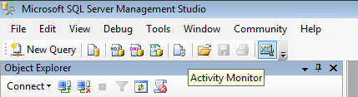

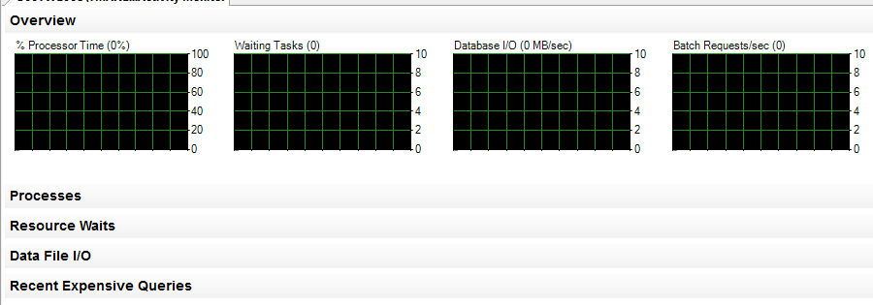

Use the Activity Monitor component of Microsoft SQL Server Management Studio to get information about users connections to the Database Engine and the locks that they hold. Activity Monitor has below options. The options are as follows:

- Process Info page
- Resource Waits
- Data File I/O
- Recent Expensive Queries

1.Process Info
Option contains information about the connections.
2. Resource Waits
Option sorts the locks by the connection, Memory, Network I/O, Backup, and Buffer I/O. This option shows information about waits for resources and includes below information.
Wait Category: The categories that accumulate wait type statistics. The individual wait types are shown in the Active User Tasks pane.
Wait Time (ms/sec): The wait time in milliseconds per second for all tasks that are waiting for one or more resources in the wait category since the last update interval.
Recent Wait Time (ms/sec): The weighted average wait time in milliseconds per second for all tasks that are waiting for one or more resources in the wait category since the last update interval.
Average Waiter Count: The number of tasks that are waiting for one or more resources in the wait category at a typical moment during the last sample interval.
Cumulative Wait Time (sec): The total amount of time in seconds that tasks have waited for one or more resources in the wait category since SQL Server was last started on the instance, or since DBCC SQLPERF was ran on the instance.

3. Data File I/O
This pane shows information about the database files for the databases that belong to the instance. This pane includes the following information.
Database: The name of the database.
File Name: The name of the files that belong to the database.
MB/sec Read: Recent read activity, in megabytes per second, for the database file.
MB/sec Written: Recent write activity, in megabytes per second, for the database file.
Response Time (ms): Average response time, in milliseconds, of recent read-and-write activity to the database file.

4. Recent Expensive Queries
This pane shows information about the most expensive queries that have been run on the instance over the last 30 seconds. The information is derived from the union of sys.dm_exec_requests and sys.dm_exec_query_stats, and includes queries in process and queries that finished during the time period. This pane includes the following information.
Query: The query statement that is being monitored.
Executions/min: The executions per minute for the query.
CPU (ms/sec): The rate of CPU use by the query.
Physical Reads/sec: The rate per second of physical reads by the query.
Logical Writes/sec: The rate per second of logical writes by the query.
Logical Reads/sec: The rate per second of logical reads by the query.
Average Duration (ms): Average duration in milliseconds of running this query.
Plan Count: The number of cached query plans for this query. A large number might indicate a need for explicit query parameterization.

Click the Filter button to apply a filter, reducing the amount of information displayed.

Use Activity Monitor when troubleshooting database locking issues, and to terminate a deadlocked or otherwise unresponsive process.

Refreshing the Activity Monitor in SQL Server 2014:
In SQL Server 2014, there’s a small blue link off to the left called “View Refresh Settings” that will allow you to set a polling interval for the screen to refresh. That’s far more useful, although it does take a hit on the server when you do it. That’s why it’s best to turn this on when you need it, and off again when you’re done monitoring. You can also just click the “Refresh” button at the top if you like, which is the more preferable one.

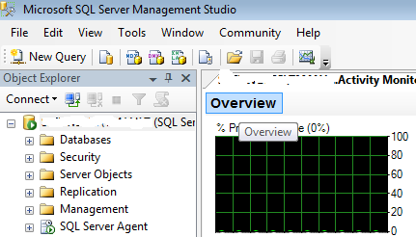

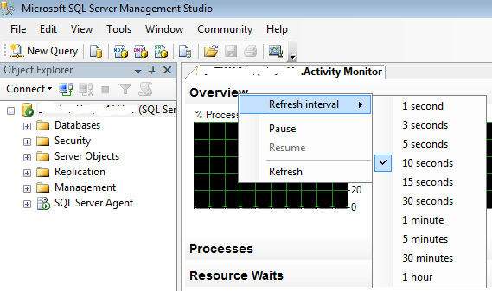

Specify the refresh timings in seconds and click OK.

Permissions required
To view the Activity Monitor the user needs VIEW SERVER STATE permission on a SQL Server 2005 server.
To view the Activity Monitor the user needs SELECT permission to the sysprocesses and syslocks tables in the master database on a SQL Server 2000 server. Permission to view these tables is granted by default to the PUBLIC database role.
Permission to KILL a process default to the members of the sysadmin and processadmin fixed database roles, and are not transferable.

In SQL Server Management Studio, connect to the server with Object Explorer, expand Management, and then double-click Activity Monitor.

Note

Steps to determine Microsoft gets information to Activity Monitor:
If we to find out how Microsoft gets information for a screen in activity monitor. Just open the SQL Server Profiler tool and begin a default trace before you start looking at a screen. Then open the screen you’re interested in, and jump back to the Profiler tool. Stop the trace process, and read the Transact-SQL that the screen is sending. You’ll have the entire script right there in front of you.

Reference
- https://docs.microsoft.com/en-us/sql/relational-databases/performance-monitor/open-activity-monitor-sql-server-management-studio

